

**Project Proposal**

**Members:**

Hafiz Muhammad Ammar Khan 007

Ammar Ahmed 043

Usama Bin Israr 178

Muhammad Zubair 234

**Project Name:** Lifeline Appointment System

**Version:** v1.0

**Prepared By:** Usama Bin Israr

**Organization:** Codentix Software Systems

**Date:** 02nd April, 2018

**Table of Contents**

1. Introduction
2. Purpose
3. Scope
4. Functionality
5. Flowchart
6. **Introduction**

We are developing a system that can help patients search for relevant doctors and will also be able to set an appointment with that doctor.

* **Company Name:** *Codentix Software Systems*
* **Company Logo:**



* **Company Hierarchy:**

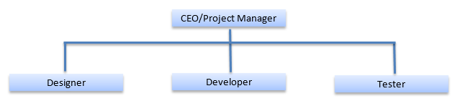

1. **Purpose:**

The purpose of this system is to help user reduce the time and money consumption while searching for a doctor and getting the specialized treatment that they want.

1. **Scope:**

This project will be associated with the health care department whose information could easily be accessible from our database.

1. **Functionality:**

The functionality of this system is to provide detailed information about the doctors, so that the user could get the best possible treatment of a particular disease.

1. **Flowchart:**

